**Python Functions**

**Python Functions** is a block of statements that return the specific task. The idea is to put some commonly or repeatedly done tasks together and make a function so that instead of writing the same code again and again for different inputs, we can do the function calls to reuse code contained in it over and over again.

Some **Benefits of Using Functions**

* Increase Code Readability
* Increase Code Reusability

**Python Function Declaration**

The syntax to declare a function is:

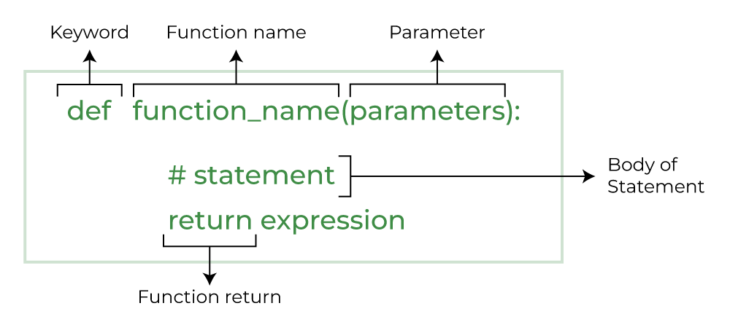

*Syntax of Python Function Declaration*

**Types of Functions in Python**

Below are the different types of functions in [Python](https://www.geeksforgeeks.org/python-programming-language/):

* **Built-in library function:** These are [Standard functions](https://www.geeksforgeeks.org/python-built-in-functions/) in Python that are available to use.
* **User-defined function:** We can create our own functions based on our requirements.